- Begin by logging into your existing account. (Ctrl + Click on follow link)
  - If you don’t remember your password, you can use the “Forgot Password” Link to request an email to reset it.
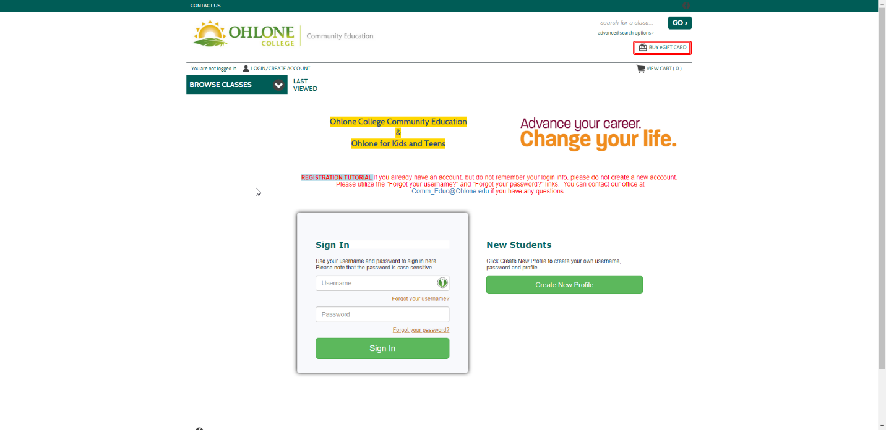

- After logging into your account navigate to Menu > My Classes > Current Registrations.
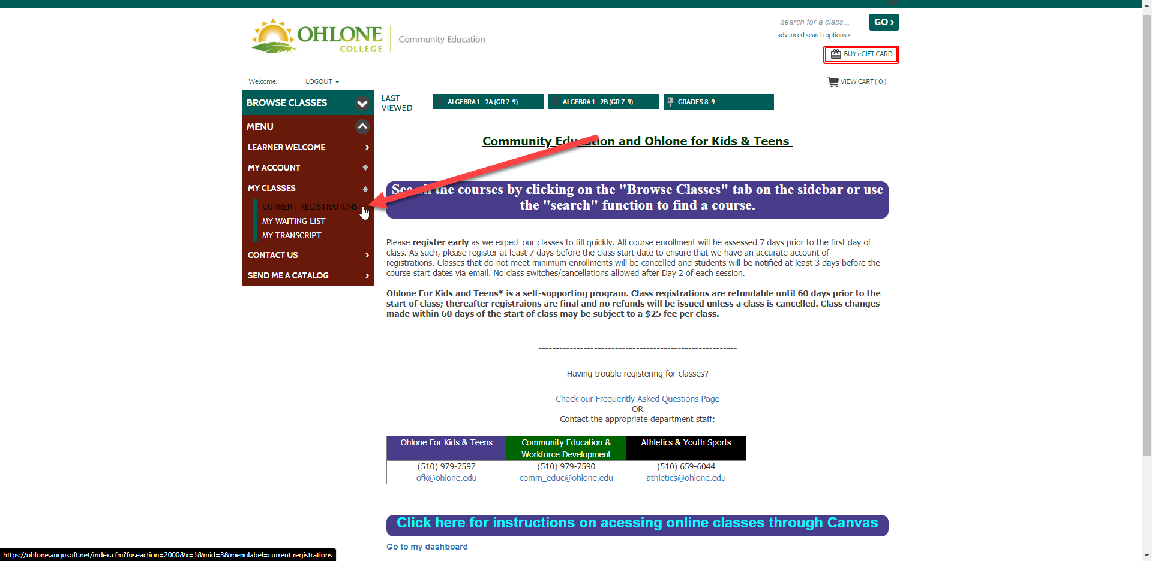

- From your current registrations click on the Go To Class link.
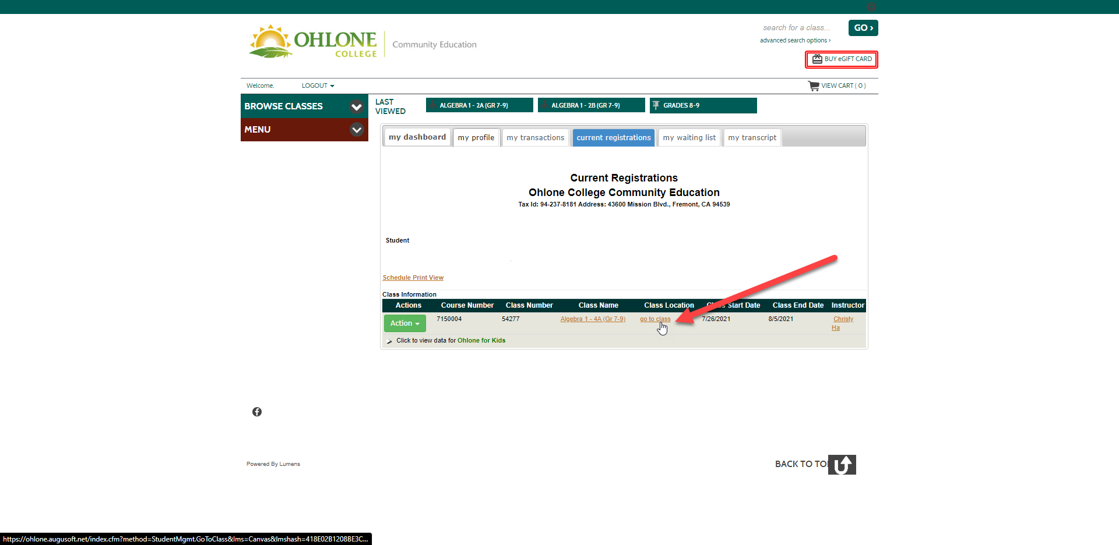

- This page will show you your Canvas login information. Remember to reveal the password using the Eye icon and copy it (Ctrl +C).
- Select Go to Canvas, this will open a new tab for the Canvas login page.
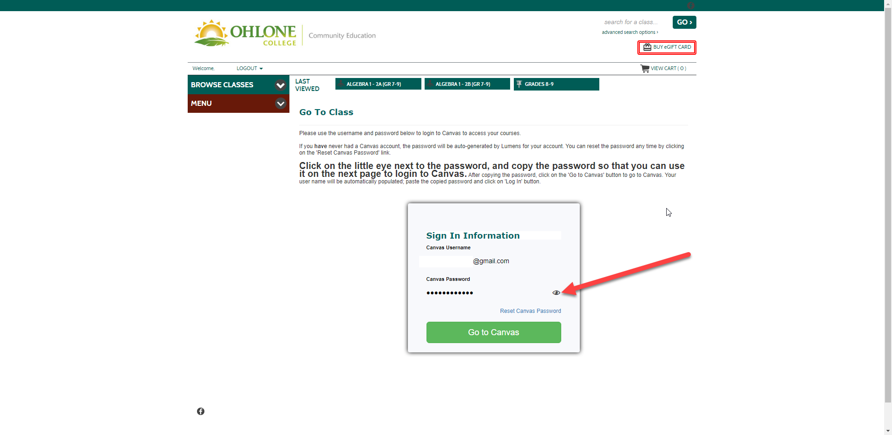

- Finally paste (Ctrl+V) the password from the previous page into the password field.
  - Your username will already be populated. Select Login to access your classes.
